Bahria University,

Karachi Campus



LAB EXPERIMENT NO.08

LIST OF TASKS

|  |  |
| --- | --- |
| TASK NO | OBJECTIVE |
|  |
| 1 | **Configure RIP on the following network and show all necessary configuration steps for each router.** |
| 2 | **Configure RIP on the following network and show all necessary configuration steps for each router.** |
|  |  |
|  |  |
|  |  |
|  |  |
|  |  |

Submitted On:

Date: 11/12/22

1. **Configure RIP on the following network and show all necessary configuration steps for each router.**



**Solution:**

Assigning IP address:

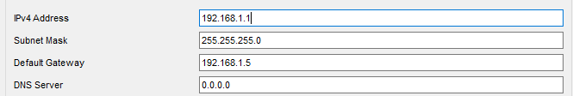 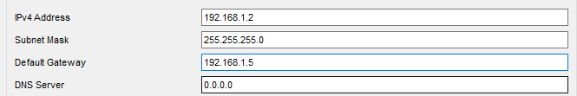 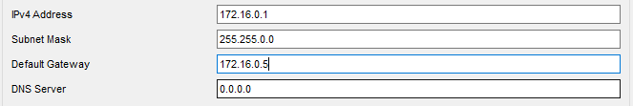 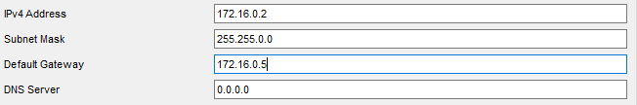

Router configuration Router 1:

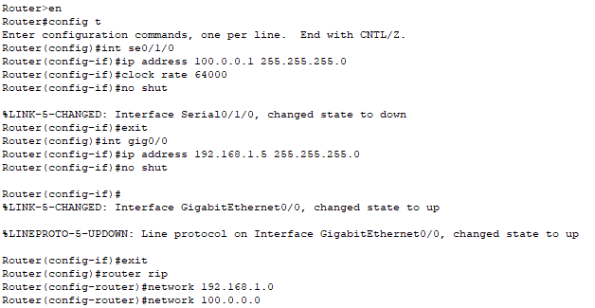

Router Configuration router 2:

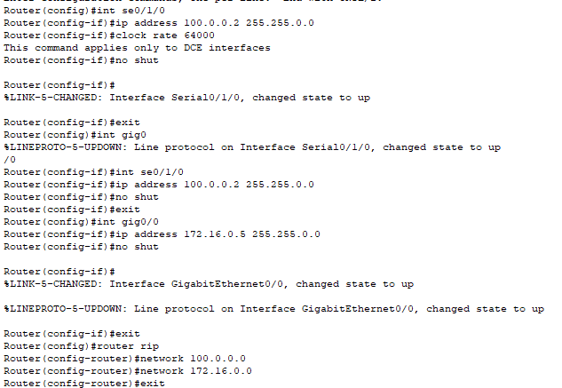

Router Rip:

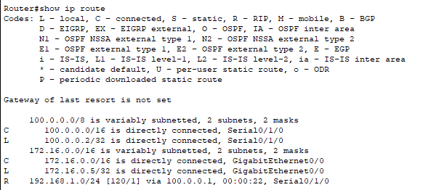

Ping Result:

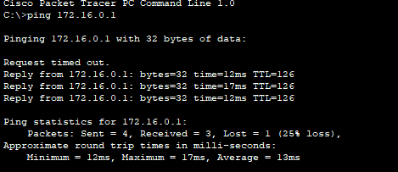 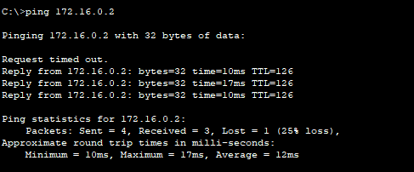

1. **Configure RIP on the following network and show all necessary configuration steps for each router.**



Solution:

Assigning IP’s:

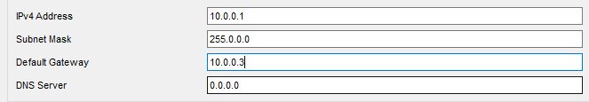 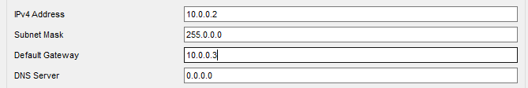 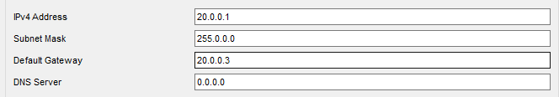 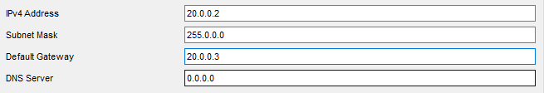

Router 1 configuration:

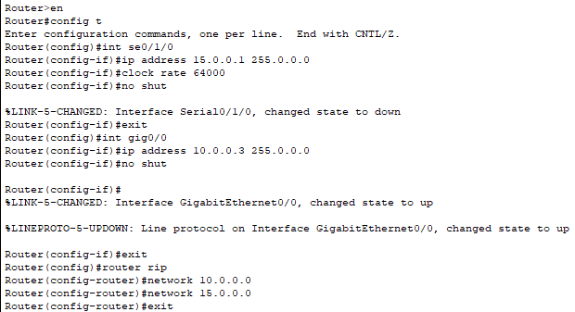

Router 2 Configuration:

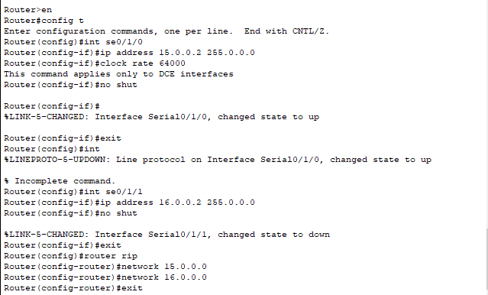

Router 3 Configuration:

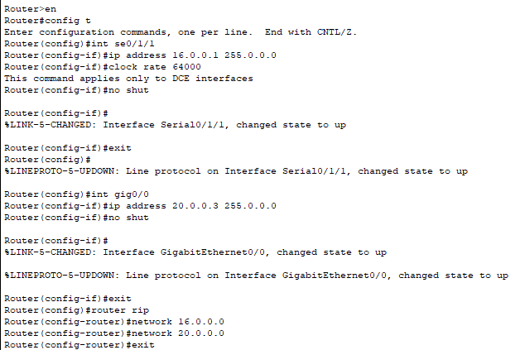

Show Ip Route:

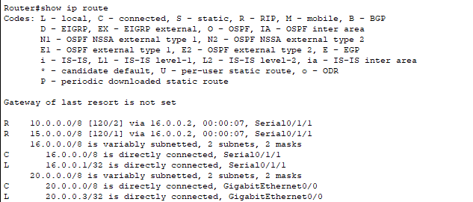

Ping Results:

